STUDENT WORKSHEET • INDEPENDENT CODING

Week 12 / Day 3 — Readable CSS
Lakbay Batangas Tours | Colors, contrast, typography and keyboard focus
Name / Team: __________________________________________ Date: __________________

Challenge
Continue your existing Lakbay Batangas Tours project. Improve the appearance and accessibility of its CSS while preserving all HTML and the CSS work completed in Days 1–2. Your code must produce the visible results below; no starter code or complete solution is provided.

Expected output — visual references
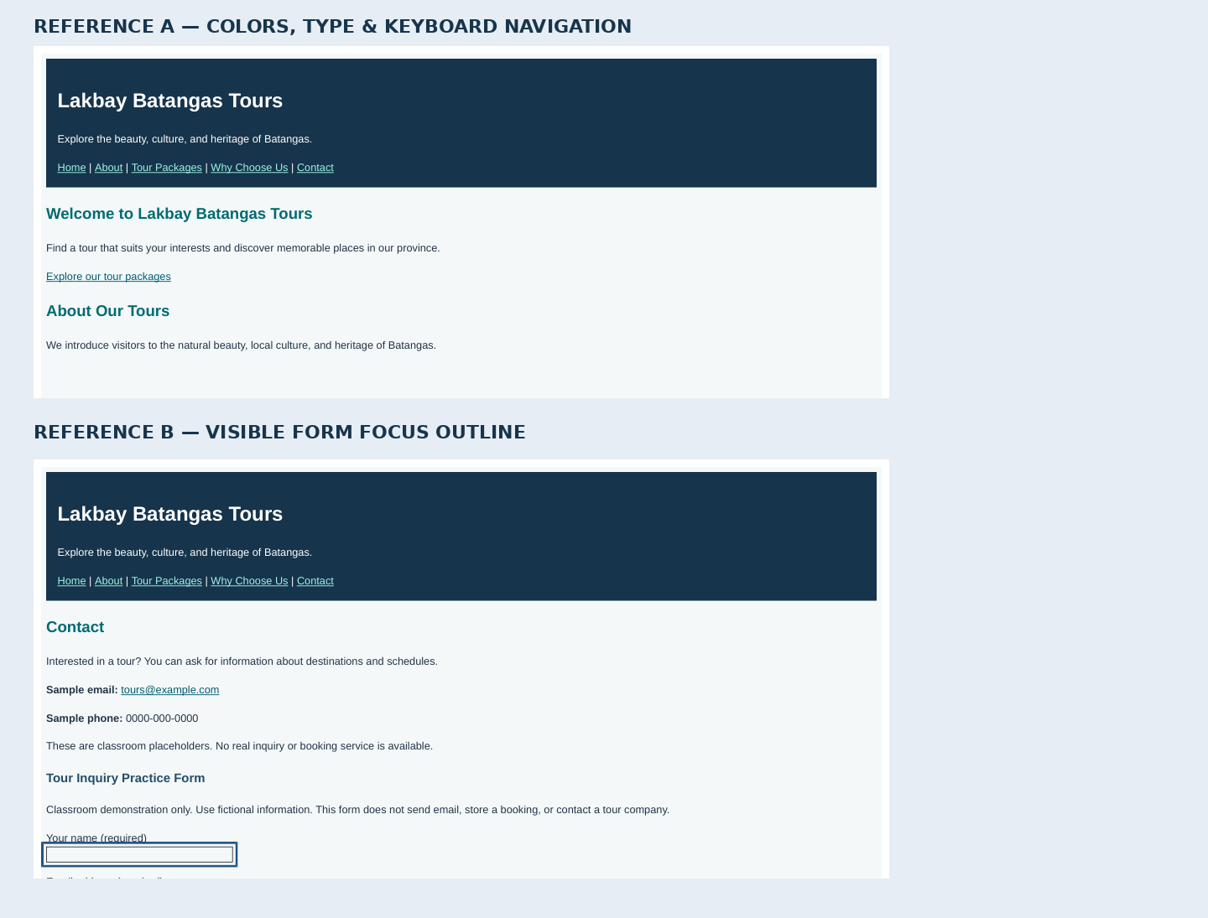
Reference A demonstrates readable colors, type, and recognizable links. Reference B illustrates the expected outline when a text field has keyboard focus. Exact wording and pixels can differ from your retained HTML; the behavior must match.
Work in the SAME index.html and css/style.css from your project. Do not recreate the webpage, remove earlier sections, or add unrelated box-model layouts.

STUDENT WORKSHEET • ACCEPTANCE CHECKPOINTS

Required Checkpoints
You must independently decide what CSS to write. The instructor checks what the browser actually displays and does.

CHECKPOINT 1 — Preserve the full website
The five existing sections are still visible and reachable. Keep all three tour descriptions, comparison table, local Taal Lake image with its caption and credit, and the practice inquiry form. Do not break the current external stylesheet link.

CHECKPOINT 2 — Improve foreground/background contrast
Normal paragraph text remains easily readable against its background. The dark header has light legible text, and the heading and link colors remain recognizable against nearby backgrounds. Do not use color alone to identify a link or show important information.

CHECKPOINT 3 — Make typography intentionally readable
Use an appropriate body font with a fallback, a comfortable text size, and enough line spacing for longer paragraphs. Main headings, section headings, and smaller tour headings form a consistent visual hierarchy without changing the semantic HTML heading levels.

CHECKPOINT 4 — Show visible link states
Navigation and inline content links are recognizably clickable at rest. The visitor can see a difference when hovering a link. Previously visited links remain readable. Keep link text meaningful and make sure all existing destinations still work.

CHECKPOINT 5 — Demonstrate real keyboard focus
Without using the mouse, press Tab to focus a navigation link and take a screenshot showing a strong visible focus indicator on the dark header. Continue tabbing to the Contact form; focus a text input and take another screenshot showing its visible focus outline on the light form area. Shift+Tab should move backwards.

CHECKPOINT 6 — Testing, evidence, and Git
Check all main navigation links, at least one inquiry link, image loading, and the form’s required-field validation. Record the result of each test. Submit the updated css/style.css, your original index.html, two focus screenshots, a readable-page screenshot, and a meaningful Git commit without resetting or deleting earlier work.
SUBMISSION Project folder/repository + expected-output screenshots + test record + latest commit ID. Use fictional data in form testing.


